Spring Boot and Angular are a popular combo when building a web app. Let's take a quick look to see work flow of the application.

The application having Create, Retrieve, Update, Delete operation. I have also used a REST API i.e Spring Rest Webservice and SpringData JPA with an H2 database for accessing the data as data source.

For Front End Technology, I used Angular 6.1 which is running on Angular CLI server, default port is 4200.

First I run Spring Rest Webservice on Tomcat server then I started Angular Application which is running on Angular CLI server.Once Angular CLI server started the following page will come up in default browser. **Please refer Image: 1**.

* On hit of **New User**  button the following page will come up in browser and we can enter the First Name and Last Name and click save for saving the user in Database. So, I created here now “DemoforAgile”, which will be listed in table. **Please refer Image: 2 and 3**.

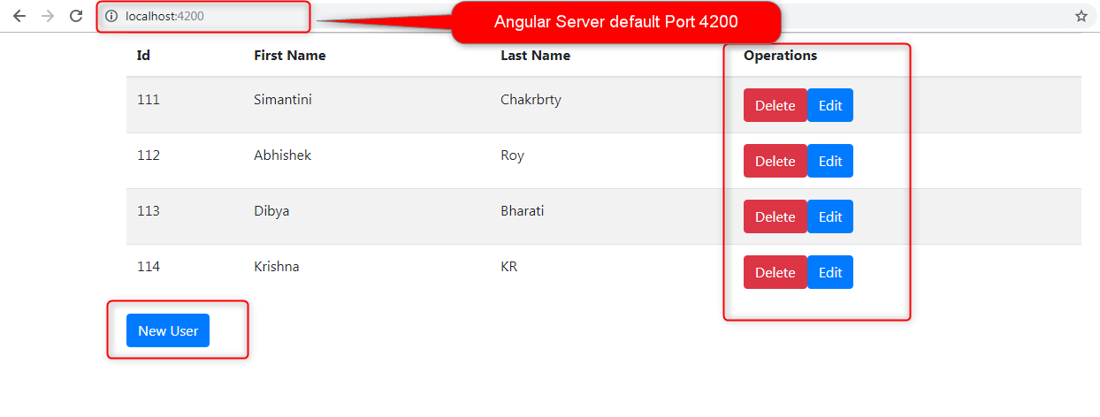

**Image:1**

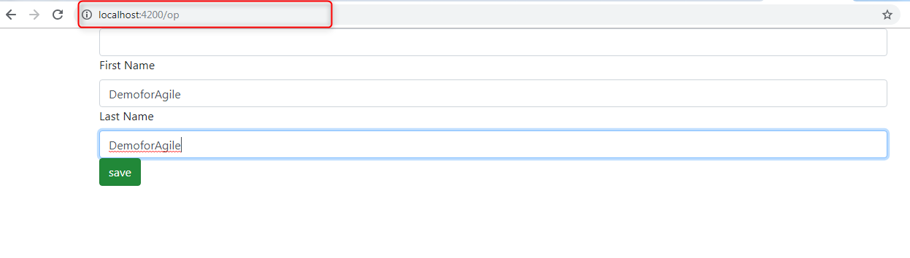

**Image: 2**

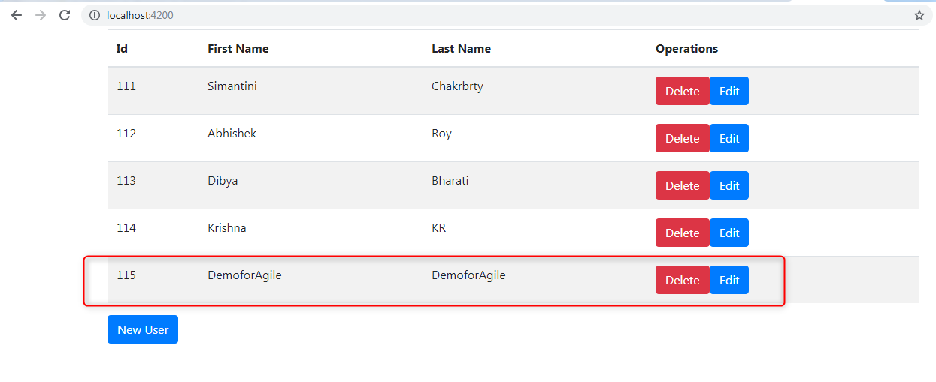

**Image: 3**

* On Click of **Edit** button, this following page will come up with the user’s details. Now I modified the **DemoforAgile** to **AgileIDC** and then saved the record. **Please refer Image: 4 and 5**.

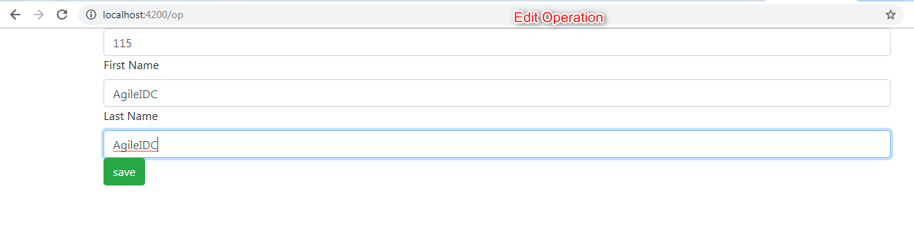

**Image: 4**

* AgileIDC is listed in the table. **Please refer Image: 5**.

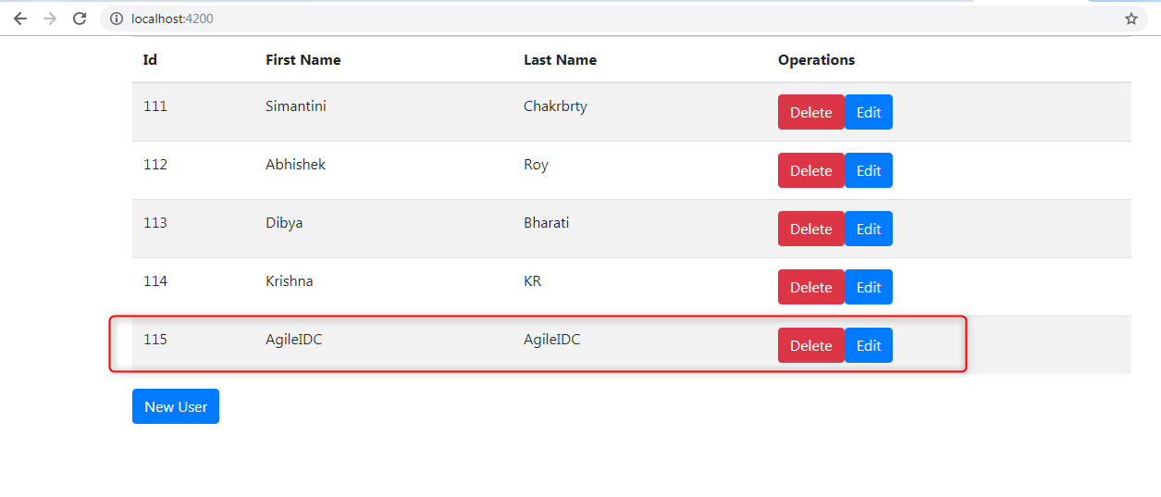

**Image: 5**

* Now I am moving on for delete operation, the record will be deleted by clicking on delete button. . **Please refer Image: 6.**

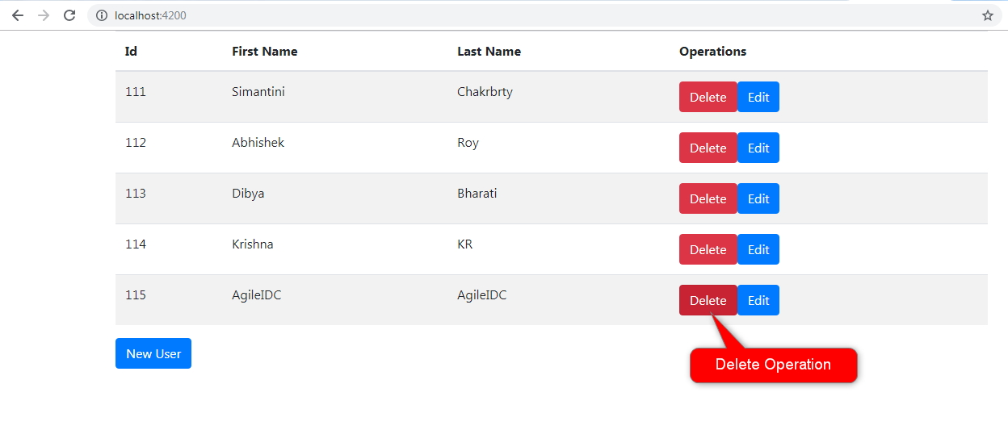

**Image: 6**

* After deleting the user, these are the users listing in the tables now.

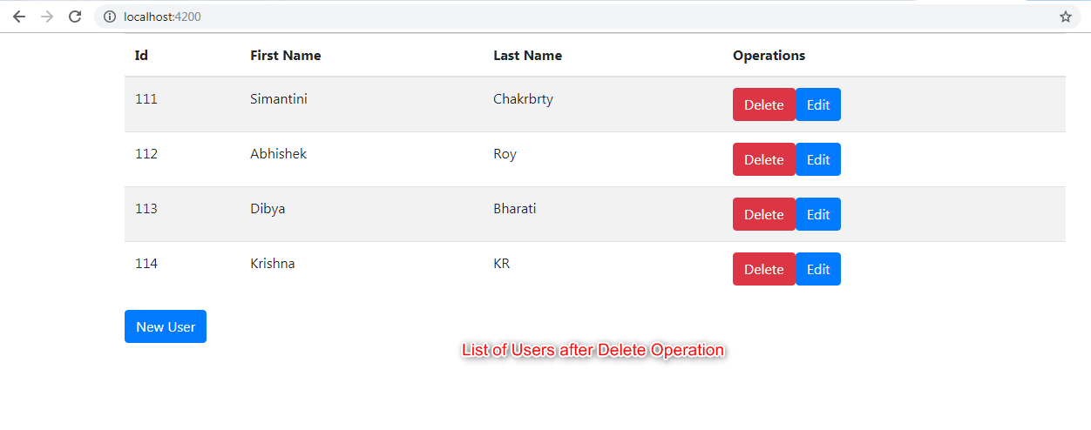

**Image: 7**

**Please feel free to raise any question ☺.**

The package structure for Angular application is as follows: 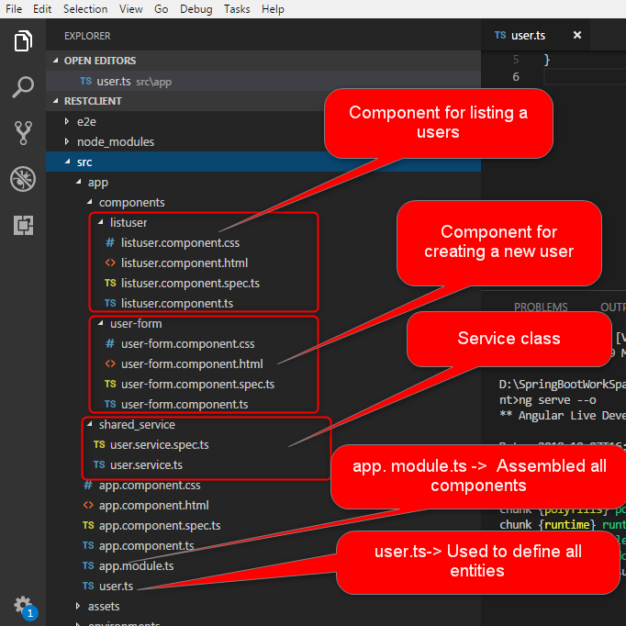

**Image: 8**

The package structure for Spring Boot application is as follows:

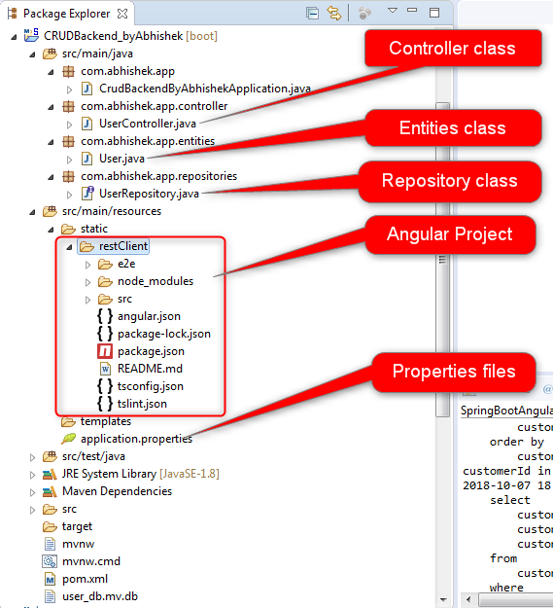

**Image: 9**